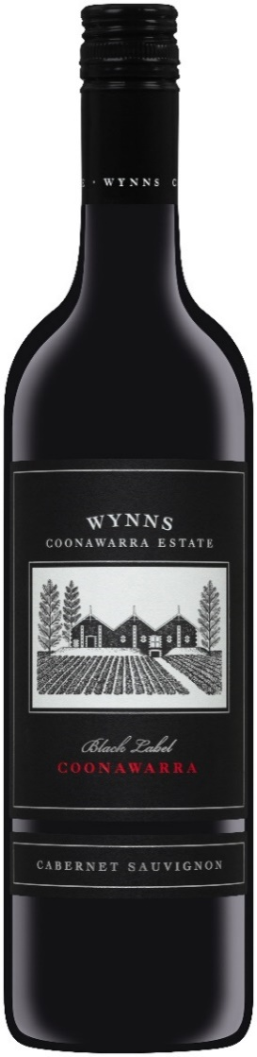

Black Label Cabernet Sauvignon
2018

Wynns Black Label Cabernet is a true icon of Australian wine. First produced in 1954, it has a reputation for ageing gracefully and displaying excellent varietal and regional characteristics. The wine is produced from only the top quality 20 to 25 per cent of Cabernet Sauvignon fruit grown in our terra rossa vineyards.

A wine of style and stature - and a perennial favourite in auction circles - ‘Black Label’ is one of Australia’s most collectable wines and Australia’s benchmark Cabernet Sauvignon. It consistently delivers potential for medium to long-term cellaring.

Winemaker Comments: Sue Hodder

Variety
Coonawarra Cabernet Sauvignon

Vintage Conditions 2018
2018 is an excellent Coonawarra Cabernet vintage. Very Intense purple colours are coupled with varietal fruit and ripe tannins. Winter and Spring rainfall was excellent at 20% above long term averages, soil moisture was replenished, and limestone aquifers recharged arm Summer temperatures advanced veraison by two weeks, to the end of January. A strong coastal upwelling cooled March, and extended the ripening period such that Cabernet was harvested in line with long term harvest dates (6th April) predominantly from the last week of March through the first two weeks of April. The yields were moderate, and the slow cool ripening was very even.
Wine Analysis
Alcohol 13.9%
pH / Acidity / Residual Sugar pH 3.62, TA – 6.3G/L, RS – 0.4G/L
Peak Duration
Enjoy on release, or cellar carefully until 2040
Maturation
Matured for 14 months in 21% new French oak with the remainder in up to three year old French oak.
The Barrels are predominantly Hogsheads with some Barriques and vats.
Colour
Deep Red colour.
Nose
Nose of Dark cherry and lavender imbued with underlying dried mint.
Palate
The 2018 Black Label Cabernet is a combination of dark fruit and finesse.
Initially the palate is soft and round, but a fine tannin framework provides structure and length on the palate.
A beautifully balanced, medium- weight Cabernet with all the hallmarks of this 20heritage label. Pristine varietal cabernet fruit balanced for guaranteed cellaring.
Perfect Pairing
Fish tacos with a green salsa.
Why?
We have always acknowledged Black Label Cabernet as a great pairing with spicier fish dishes. At Christmas in Texas, I tested the 2018 with Grilled Fish tacos. The cilantro/coriander salsa complimented the leafy Cabernet notes beautifully.

